Beauty Synthesis Unit Name: _______________________________

Task: Rank the following paintings from the most beautiful to the least beautiful. (Not whether you think that it is interesting/good art, but whether or not it is beautiful). Record a few points about your thinking as you rank each piece.
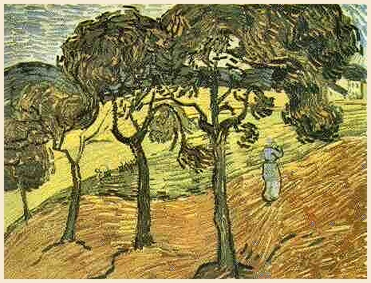

“Landscape with Trees and Figures”

Vincent Van Gogh
November 1889

Ranking #_____

Notes:_____________
__________________
__________________
__________________
__________________
__________________

“Landscape with Two Figures”  Pablo Picasso  1908  Ranking #_____  Notes:_____________  __________________  __________________  __________________  __________________  __________________ | 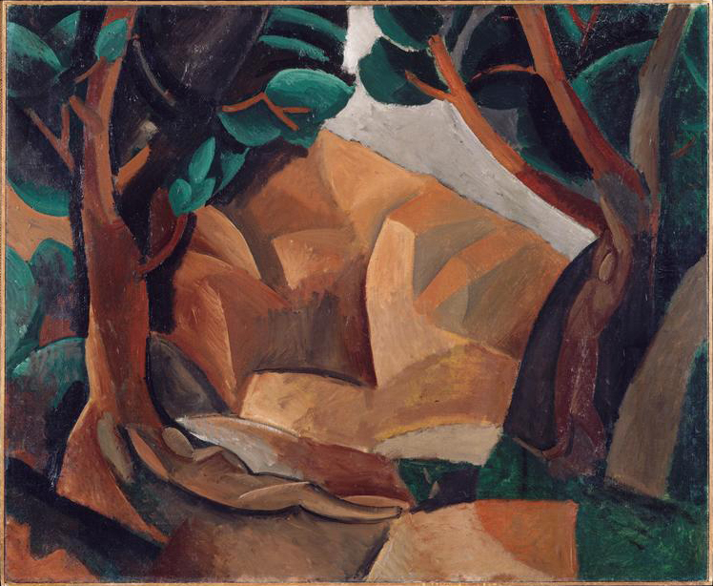
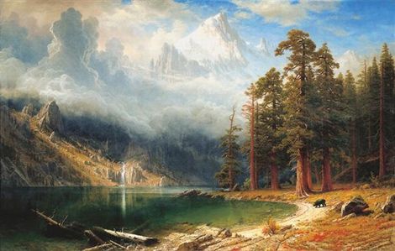

Mount Corcoran

Albert Biestadt
1876

Ranking #_____

Notes:____________
__________________
__________________
__________________
__________________
__________________

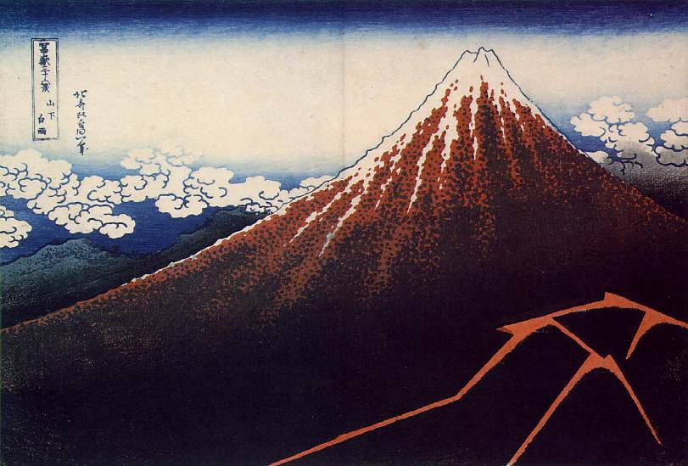
“Thunderstorm at the foot of the mountain”

Katsushika Hokusai
1830-31

Ranking #_____

Notes:_____________
__________________
__________________
__________________
__________________
__________________

“Only Poetry Remains”  Carl Beam  2002  Ranking #_____  Notes:_____________  __________________  __________________  __________________  __________________  __________________ | 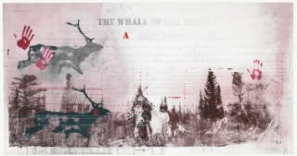

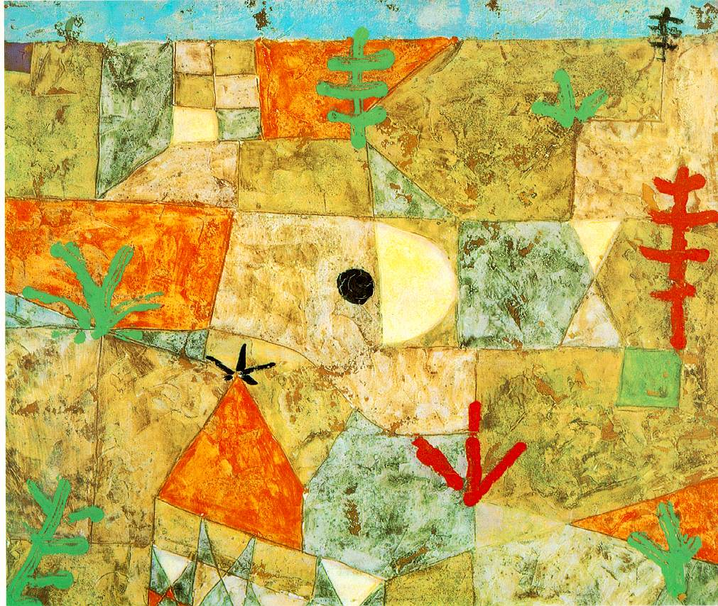
“Southern Gardens”
Paul Klee
1936

Ranking #_____

Notes:_____________
__________________
__________________
__________________
__________________
__________________

“Mother Earth”  Roy Henry Vickers  2013  Ranking #_____  Notes:_____________  __________________  __________________  __________________  __________________  __________________ | 

