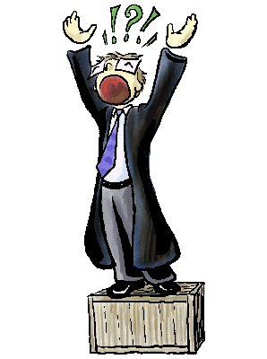
What Makes a Good Rant?

Rant Assignment

What is a Rant Poem?

•

A rant is an opinionated speech

in the
form of a poem about a current topic

•

It usually expresses a position

how
(
you feel about something)

•

It sometimes

involves taking a stance
about something important

•

Rants are usually w
itty
,
humorous,

and

entertaining

•

They are designed to leave
a las
ting
impression about the topic

•

The point of a rant is

to communicate
your frustration about a given issue

Clear structure
Intro – Captures attention and quickly
establishes the topic of the rant.

Middle –Provides challenging
statements which help the listener/viewer recognize the main point(s) of the rant….the “AHA!” moment.

End – Wraps up with a statement that leaves
the listener/viewer with a deeper
understanding of the topic.
- May contain a summary with a catchy
final statement.
- May also suggest what people should
do about the topic (a call to action).

Current Topic
- Topic should be something most
people can relate to— events in the
media, human behavior, new fads, are
all hot topics.

- Your topic should not be:
(a) threatening,
(b) include profanity or
(c) seriously harm an individual or ruin
an organizations’ reputation.

