The Great Debaters Film Response Name(s)________________________________
English 11
Total marks: 34
- Where does the term “lynching” come from? What does it mean? (2)
______________________________________________________________________________
______________________________________________________________________________
______________________________________________________________________________
______________________________________________________________________________

- What was Jim Crow? (1)
____________________________________________________________________________________________________________________________________________________________
- Why do you think Lowe gets drunk and throws his relationship with Booke away after seeing the lynching? (You may think about what his conversations with Booke and James Farmer Jr. suggests about his past.) (2)
__________________________________________________________________________________________________________________________________________________________________________________________________________________________________________

- Define the following terms: (6)
- Fallacy
___________________________________________________________________________
- Syllogism
___________________________________________________________________________
- Logic
___________________________________________________________________________
- Statistics
___________________________________________________________________________
- Facts
___________________________________________________________________________

- a) What is the syllogism that the Sheriff uses to come to the conclusion, “This is what happens to a town when you let the unions in”? (2)
__________________________________________________________________________________________________________________________________________________________________________________________________________________________________________

b) What is the fallacy in his syllogism? (1)
__________________________________________________________________________________________________________________________________________________________________________________________________________________________________________

- Civil disobedience is the refusal to comply with certain laws or to pay taxes and fines, as a peaceful form of political protest.
- What does the statement “Civil disobedience is a moral weapon in the fight for justice.” mean? (1)
_________________________________________________________________________________________________________________________________________________________________________________________________________________________________
- Do you agree or disagree? Why? (2)
_________________________________________________________________________________________________________________________________________________________________________________________________________________________________
- Do you think Canada has a problem with hate crimes or prejudice? Why/why not? (2)
________________________________________________________________________________________________________________________________________________________________________________________________________________________________________________________________________________________________________________________

- What do the charts below tell us about the situation of prejudice in Canada? (2)
_______________________________________________________________________________________________________________________________________________________________________________________________________________________________________________________________________________________________________________________________________________________________________________________________________________________________________________________________________________________________________________________________________________________________________________________________________________________________

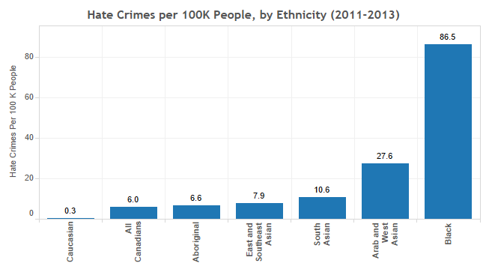

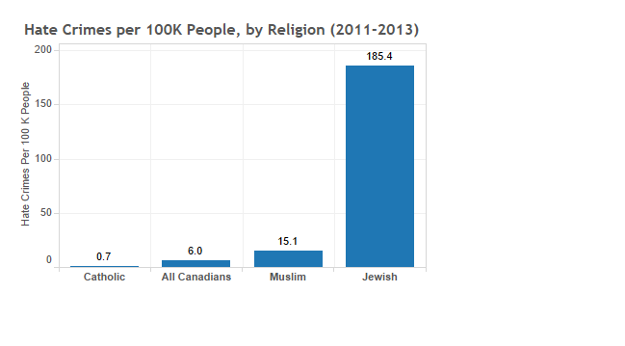

Works Cited

Cella, Matthew, and Alan Neuhauser. “Race and Homicide in America, by the Numbers.” U.S. News & World Report, U.S. News & World Report, 29 Sept. 2016, www.usnews.com/news/articles/2016-09-29/race-and-homicide-in-america-by-the-numbers.

Moskin, Arik, and Zack Gallinger. “Which Canadians Are Most Likely to Be the Victims of Hate Crimes?” The 10 and 3, 10 Nov. 2016, www.the10and3.com/which-canadians-are-most-likely-to-be-the-victims-of-hate-crimes/.

